KLE Technological University

Post and Core of Dental Analysis

(Team -1 Batch B3)

|  |  |  |  |  |
| --- | --- | --- | --- | --- |
| USN |  | NAME |  | ROLL NO |
|  |  |  |  |  |
| 01FE20BME059 |  | Bangarappa B |  | 242 |
|  |  |  |  |  |
| 01FE20BME068 |  | Nandan J |  | 243 |
|  |  |  |  |  |
| 01FE20BME076 |  | Nandish A |  | 245 |
|  |  |  |  |  |
| 01FE20BME104 |  | Om Hallikeri |  | 247 |
|  |  |  |  |  |
| 01FE20BME133 |  | Rohit Vernekar |  | 251 |
| 01FE21BME416 |  | Dayanand Hatti |  | 261 |



❖ Finite Element Analysis study of Sheep Horn Materials Applied in Post and core Restorations

1.Abstract

❖ The static structure was analysed with an existing material Titanium Alloy and a new material Sheep Horn. Input force of 250N was applied on the crown of the structure to check the following stress, strain and deformation. On further simulation the stress on Titanium Alloy was found to be more than Sheep horn. So further the tests were carried on Sheep horn.

2.Introduction

In this analysis we are using theory of dental biomechanics which deals with applications. In the current years the metallic posts are moderately being replaced by several non-metallic posts.

Post and core system is a generally used approach for treatment of structurally weakened teeth. The main objective of post and core procedure is a replacement of the decayed tooth structure in order to ease the crown support and retention of the structure.

The factors that are important to choose posts and core are remaining tooth structure, choice of material, stress distribution like modulus of elasticity.

Replacing identically treated teeth is challenging. In the past endodontists used gold and silver to retain crowns various types of post-and-core systems have been introduced to dentistry. Endodontic posts may be cast with the core such as gold and nickel-chromium (Ni-Cr) posts or they may be prefabricated such as titanium and stainless-steel posts.

Lately, non-metallic posts such as Fibber posts and ceramic posts have been introduced as alternative materials.

The motive of this study was to evaluate stress distribution in a tooth restored with posts using 3-D finite element analysis and to report their effect on the stress distribution in radicular dentin by using 3D FEA.

The material medium of a dental post is one of the elements affecting the stress distribution in dentin. The stress distribution in post-and-core systems has been studied by many researchers using experimental method.

3. Materials and methods

3.1 Material used

Sheep Horn is an impact-resistant, thermally stable and brittle material. usage of sheep horn is a very new approach in material sciences, as it is not often used in any applications.

Sheep horn is the exoskeleton of sheep and is majorly consisting of keratin epidermal layers. The Sheep horn consists of two types of keratins, known as α keratin and β keratin.

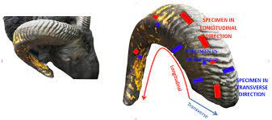

❖ Mechanical Properties of these materials are listed in Table

(Table 1)

|  |  |  |  |  |  |
| --- | --- | --- | --- | --- | --- |
| Material | Density (g/cm3) | Elastic modulus  (GPa) | Poisson’s ratio | Bulk modulus  (GPa) | Shear Modulus  (GPa) |
| Sheep horn | 1.23 | 4.1 | 0.3 | 1.775 | 0.819 |
| Dentin | 2.12 | 30 | 0.31 | 40 | 6.2 |
| Titanium  alloy | 4.5 | 113.8 | 0.342 | 153 | 44 |

4. Simulation

❖ CAD MODEL

The CAD model of post and core is shown in the figure below. Performed in Catia (3D experience). The model Further was converted into STEP neutral format it Import into ANSYS WORKBENCH version 2022R2.Then further the Geometry clean-up was performed.

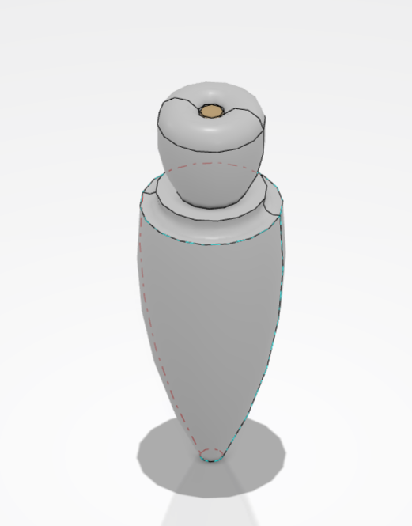

**Post**

**crown**

**Jaw**

3D models were created using 3D experience software based on the dimensions of the maxillary central incisor tooth obtained. The apical diameter was prepared to be 1.5 mm in diameter. The cores were designed to a height of 10mm with a 1.5 mm circumferential ferrule.

It was assumed that all structures and materials were homogenous, isotropic, and in possession of linear elasticity. The models assessed using ANSYSTM software were analysed. these models were subjected to loading conditions. The direction of force application was vertical at a point. For vertical loading, a load of 10N 20N was applied at the incisal edge of the crown. In the model, the resultant maximum von Mises stresses, which represent a combination of static structural, and shear stresses, can be used for predicting the stress deformation.

5.3D Finite element analysis results

❖For example we have chosen a material which has been already used in post and core dental analysis. Titanium alloy is the commonly used material for restoration of post and core. We have compared the two materials.one which is already used and the one on which we have worked i.e., Sheep Horn. The mechanical properties of Titanium alloy are represented in the Table 1.

❖We have specified the Structural analysis, stress, strain and Deformation

❖The above-mentioned factors are represented in Simulation figures presented below.

❖Sheep Horn❖

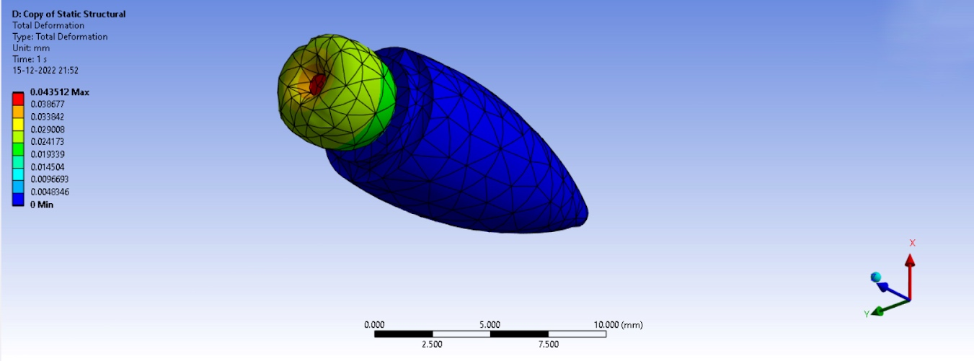

Fig .1

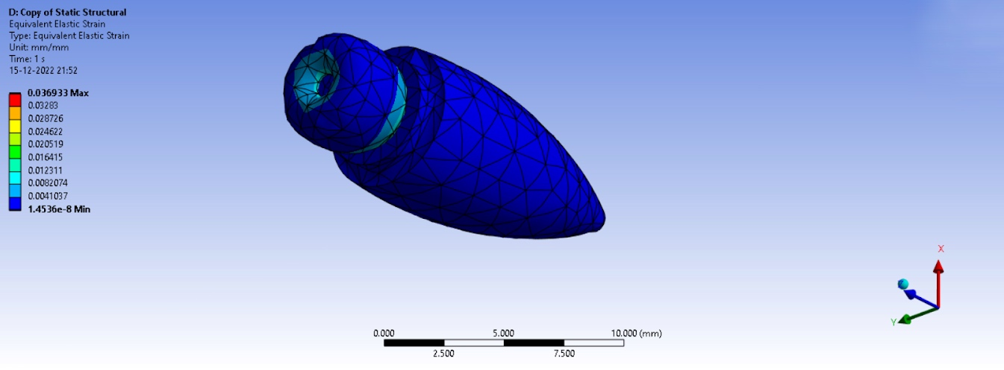

Fig.2

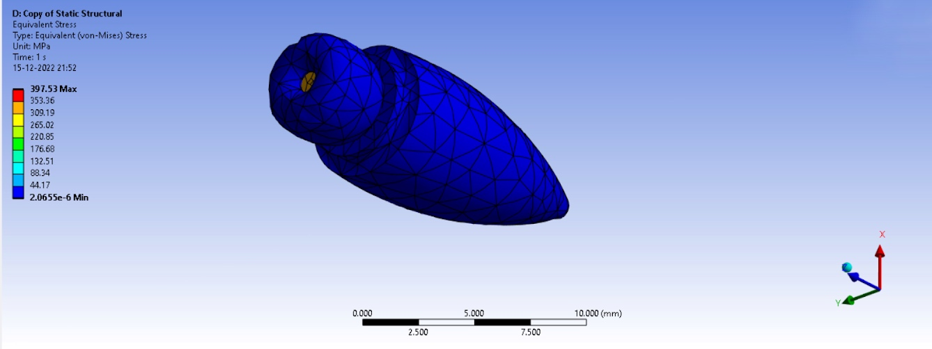

Fig.3

RESULTS:

Deformation-0.0435

Equivalent Strain-0.0369

Equivalent Stress-397.53

❖Titanium Alloy❖

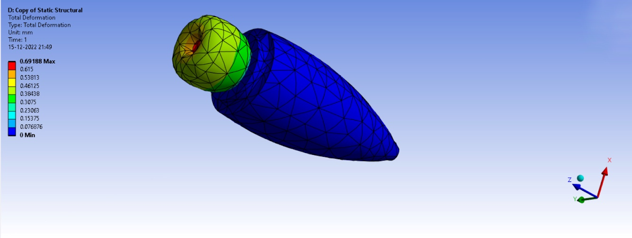

Fig.4

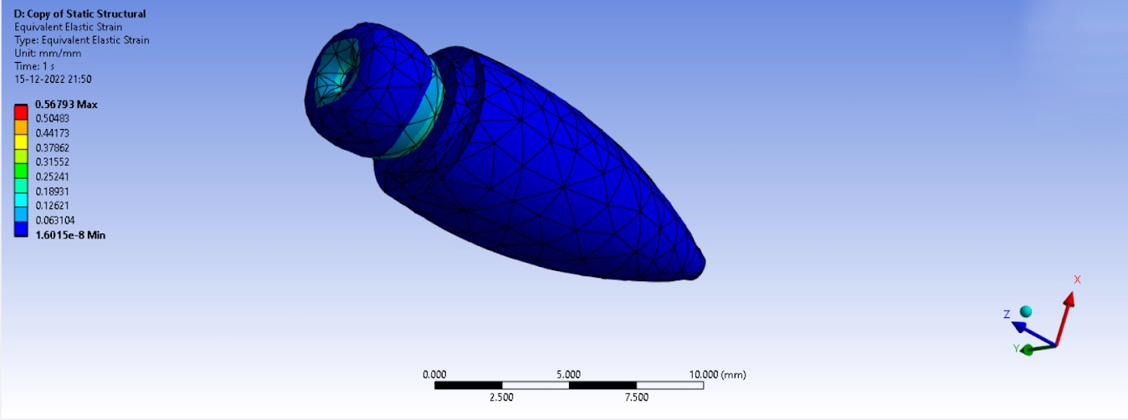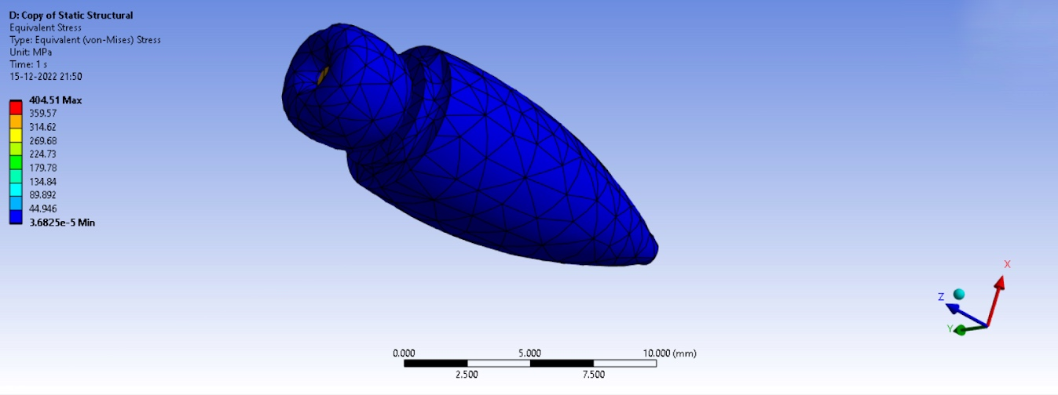

Fig.6

Fig.5

RESULTS:

Deformation-0.069

Equivalent Strain-0.5679

Equivalent Stress-404.51

6. Conclusion

Results:

❖Tooth restored with sheep horn posts and titanium alloy cores reduce the risk of debonding and root fracture. The behaviour of the sheep horn post restorations was close to the dentin.

❖The maximum stress were observed at cervical region of the post .

7.Reference

# 1. Investigation of Mechanical and Physical Properties of Big Sheep Horn as an Alternative Biomaterial for Structural Applications.

(<https://www.mdpi.com/1996-1944/14/14/4039>)

# 2. Three-dimensional finite element analysis for stress in the periodontal tissue by orthodontic forces.

# (https://pubmed.ncbi.nlm.nih.gov/3479896/)